Jimmy Tran

Assignment 1 Report

1. Screenshot below of Hadoop command running from Hadoop/bin/

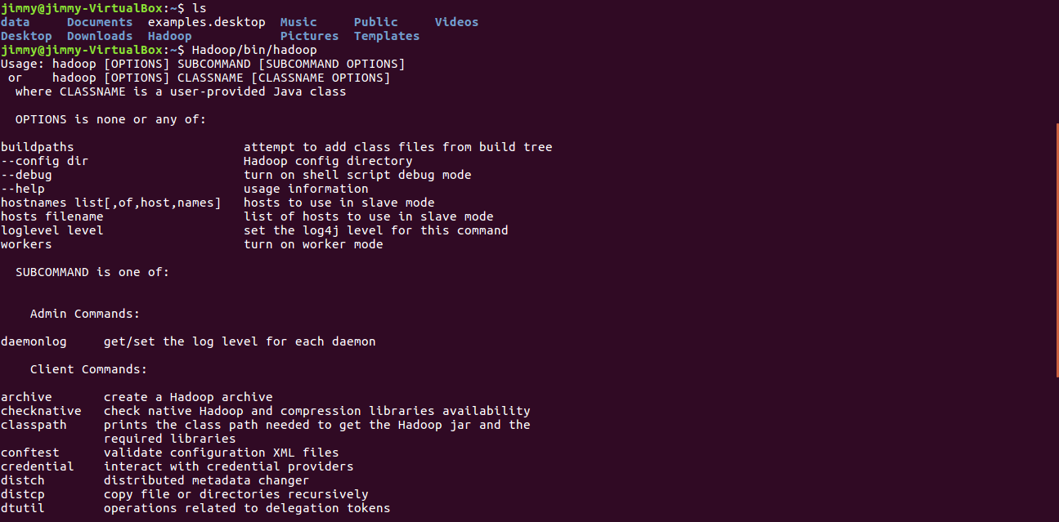

2) File peterpan.txt and test.txt uploaded to HDFS successfully

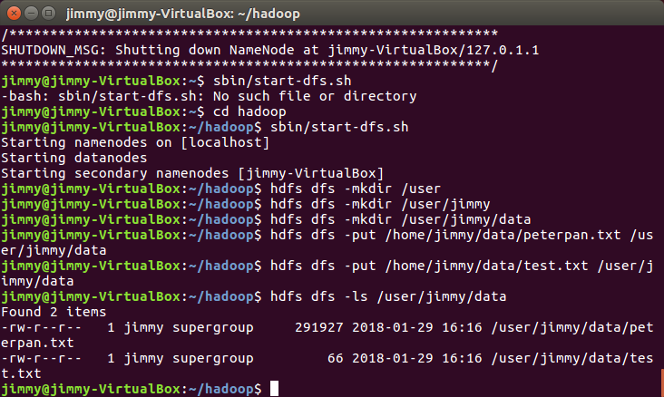

3) WordCount.java imported and exported to .jar in Eclipse.

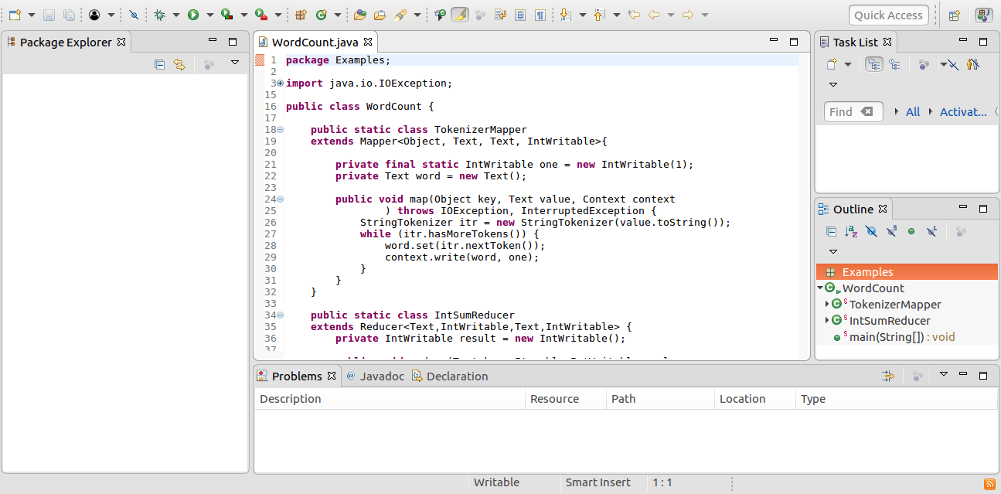

4) WordCount.jar run on peterpan.txt and test.txt

